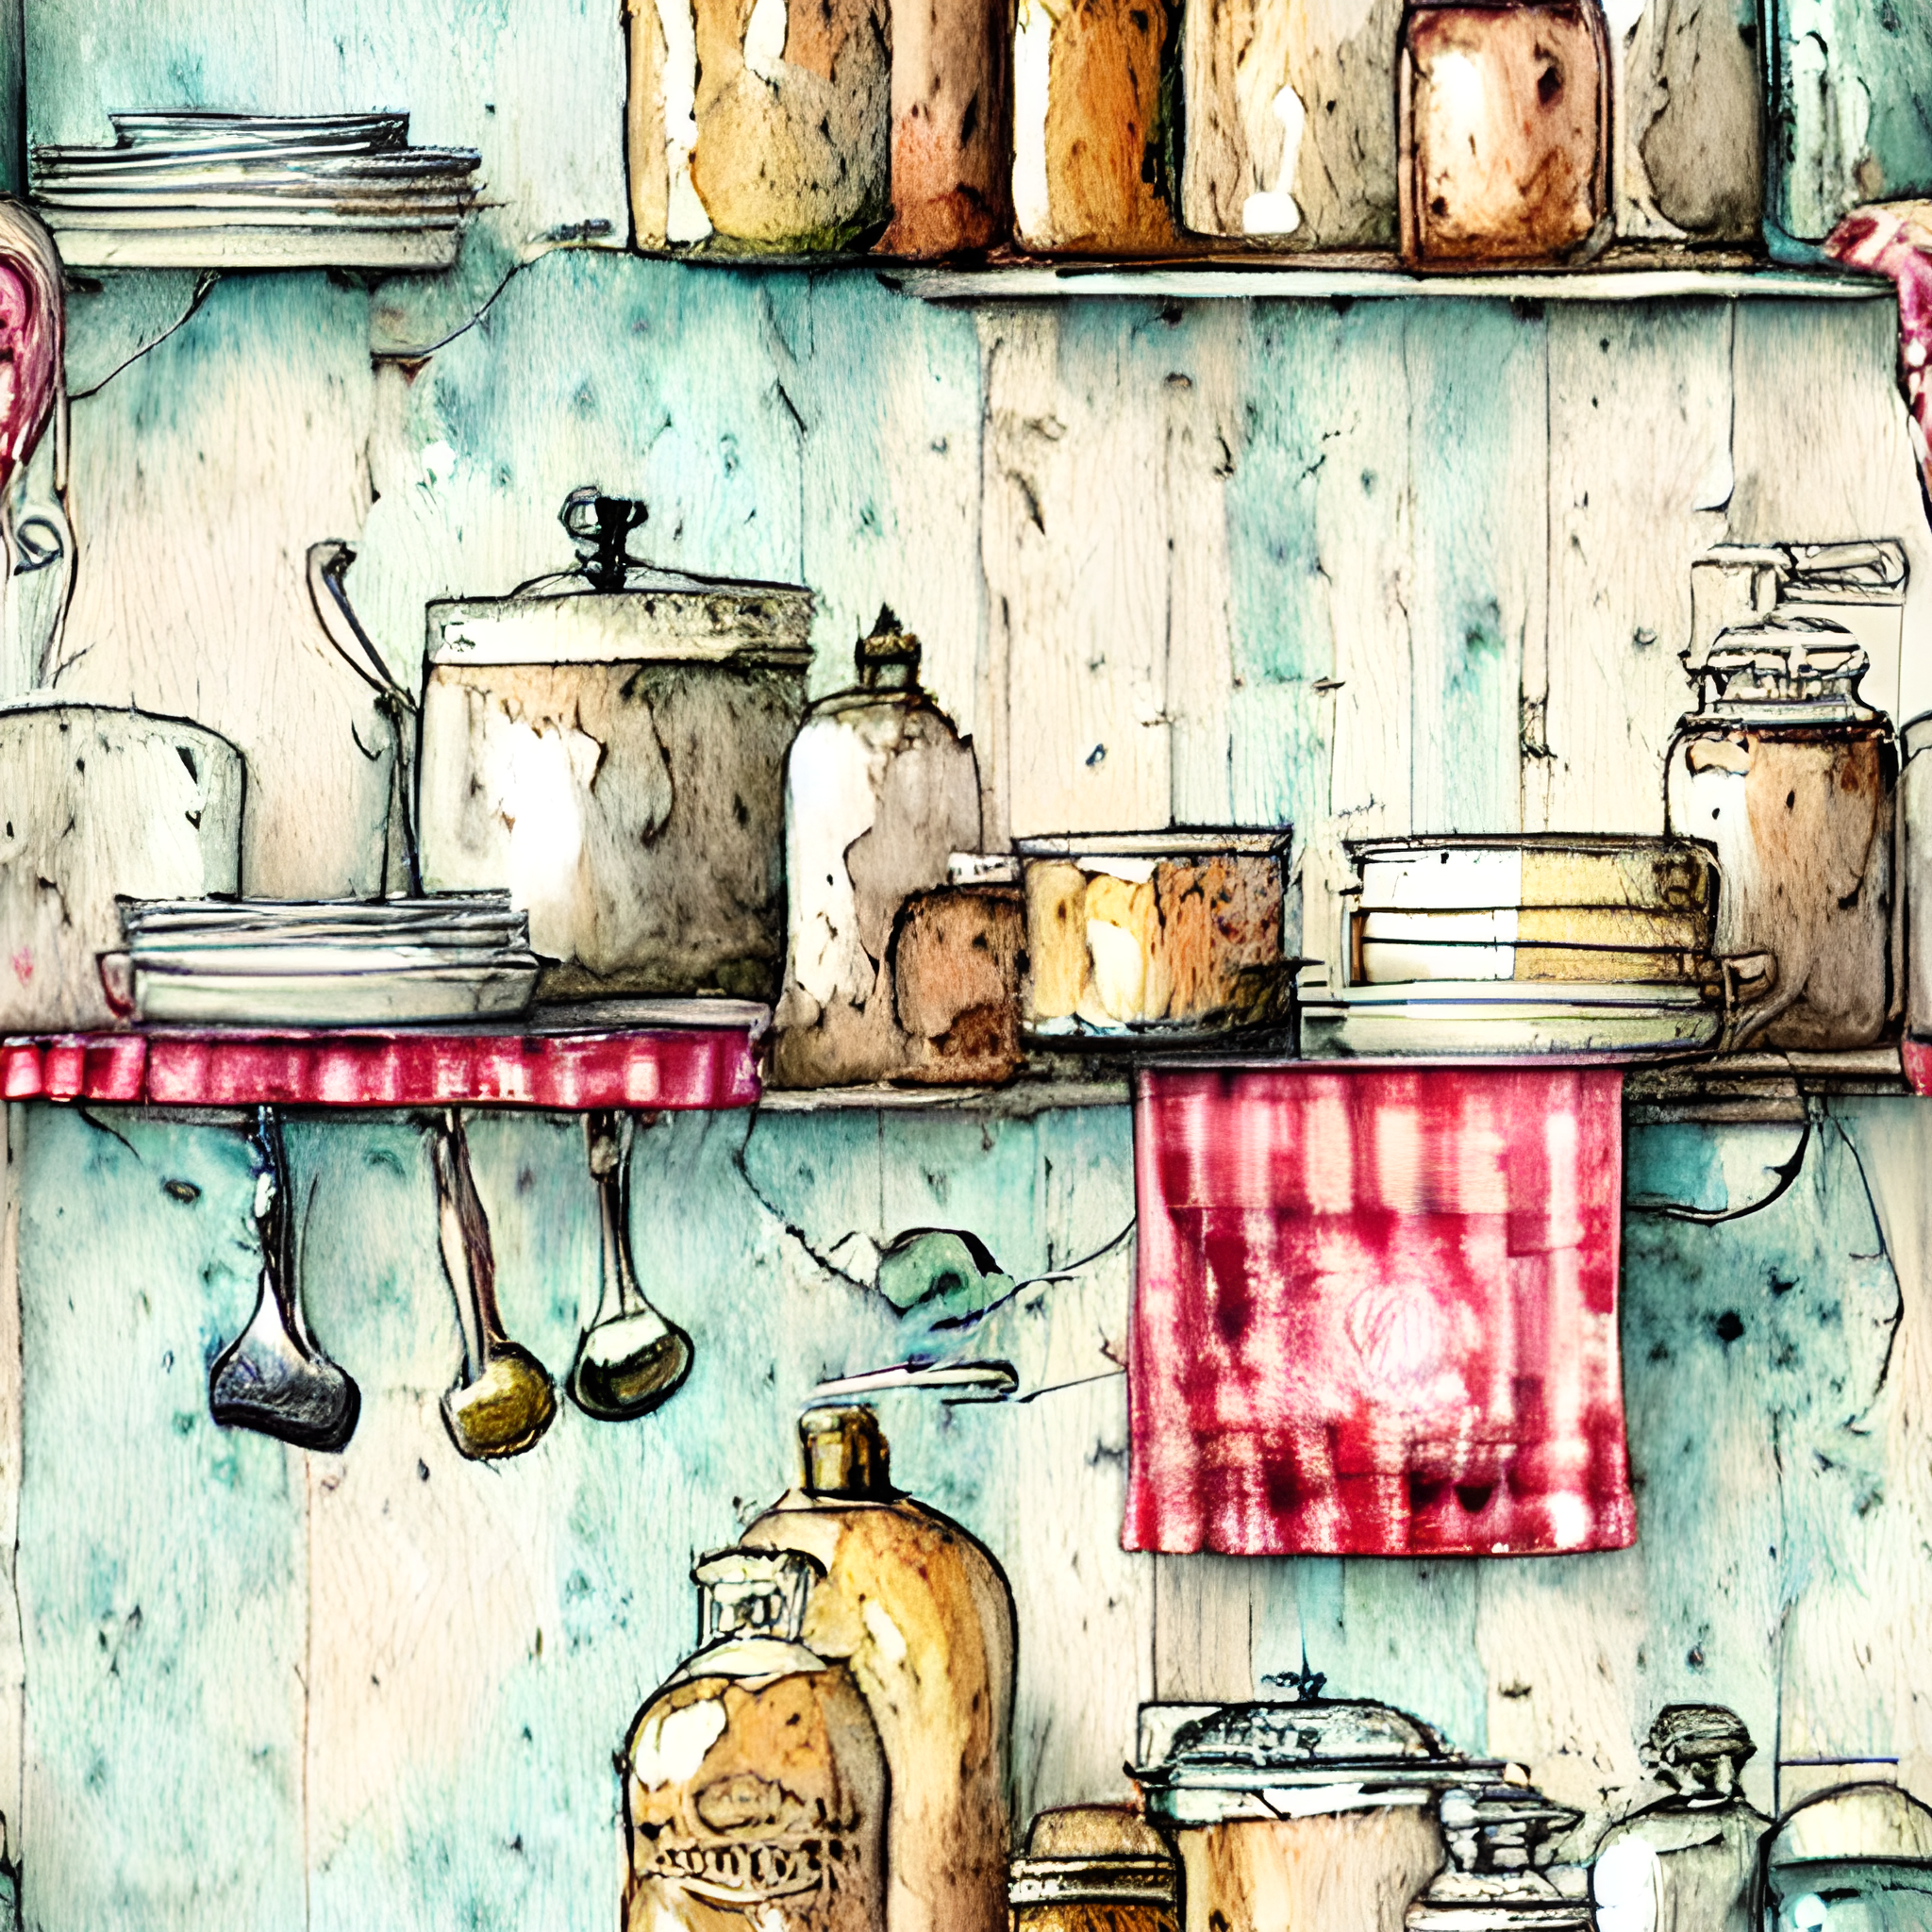
CK Cafe
breakfast

AVAILABLE ALL DAY
THE BOSS’ BREKKY Smoked salmon, poached eggs, baby spinach, avocado, tomato on toast with hollandaise sauce 20 (GFO)
BIG BREKKY bacon, eggs, tomato, mushroom, chipolata, hash brown, baked beans with two slices of toast 20 (GFO)
VEGETARIAN BIG BREKKY fried haloumi, eggs, baby spinach, tomato, mushroom, hash brown, baked beans with two slices of toast 20 (GFO)
POACHED EGGS AND SMASHED AVO ON SOURDOUGH 15 (V)(GFO)
BREKKY WRAP bacon, eggs, baby spinach, cheese, tomato, red onion, mayo 10.5 (GFO)
EGGS ON SOURDOUGH cooked your way 10 add bacon 5 (V)(GFO)
HAM AND CHEESE CROISSANT served warm 7.5
RAISIN TOAST two thick cut slices 5.5 (V)
EXTRAS tomato/baked beans 1 egg/hash brown 2 chipolata/mushroom 3 bacon/avo 5

sandwiches

AVAILABLE ON WHITE/WHOLEMEAL BREAD/GLUTEN FREE BREAD
SALAD lettuce, tomato, cucumber, red onion, carrot, beetroot, tasty cheese 7.5
add ham 1.5 add chicken 2.5
CORNED BEEF AND PICKLES home cooked corned meat 7
TASTY CHEESE AND TOMATO 5.2 add ham 1.5
CHICKEN, LETTUCE AND MAYONNAISE 7.6
EGG, LETTUCE AND MAYONNAISE 6.2
THE CK seasoned chicken, sun dried tomato pesto, avocado & tasty cheese 10
EXTRAS toasted sandwich .5 gluten free 1

melts
CHICKEN with avocado, pineapple and cheese
BASIL PESTO with capsicum, olives, mushroom and feta
SUN DRIED TOMATO PESTO with ham, avocado and cheese
ALL SERVED ON TURKISH BREAD HALF SERVE 10 FULL SERVE 16 (GFO)
burgers

ALL BURGERS SERVED WITH A SIDE OF CHIPS
TABULAM TOWER BURGER double beef patties, bacon and cheese, with egg, potato scallop, pineapple, onion, tomato, lettuce, BBQ sauce and mayo on a sesame seed bun 23.5
STEAKWORKS BURGER prime rib eye steak, onion, BBQ sauce, cheese, egg, bacon, pineapple, beetroot, tomato and lettuce on sesame seed bun 19 (GFO)
HALOUMI BURGER lightly fried haloumi cheese, hommos, parsley, mint, lettuce, tomato, cucumber, red onion, freshly grated carrot, and beetroot on turkish bread (v)(GFO) 16.5
WORKS BURGER beef patty, egg, bacon, pineapple, onion, BBQ sauce, cheese, tomato, beetroot and lettuce on a sesame seed bun 17
CHICKEN WORKS BURGER chicken schnitzel, cheese, bacon, pineapple, lettuce, mayonnaise on a sesame seed bun 15.5
PLAIN BURGER beef patty, onion, BBQ sauce, cheese, tomato, beetroot and lettuce on a sesame seed bun 13.4
LENTIL BURGER lentil patty, cheese, sweet chilli sauce, beetroot, tomato and lettuce on turkish bread (V) 13.5
CHICKEN SCHNITZEL BURGER chicken schnitzel, lettuce, mayonnaise on a sesame seed bun 12.5
FISH BURGER battered fish, lettuce and tartare sauce on a sesame seed bun 12.5
CHEESEBURGER beef patty, cheese and tomato sauce on a sesame bun 12
EXTRAS tomato/BBQ/sweet chilli sauce .3 mayo/aoili/hot chilli .5 gravy 1.6

wraps
CHICKEN CAESAR chicken, lettuce, bacon, egg, parmesan, caesar dressing 10.5
BALT lashings of bacon, avocado, lettuce, tomato, aioli 10.5
FALAFEL hommos, sour cream, red onion, falafel, tomato, cucumber, parsley, mint, lettuce, sweet chilli sauce (V) 10.5
gluten free wraps available

childrens meals
NUGGETS and CHIPS OR SALAD 8
FISH BITES and CHIPS OR SALAD 8.5
SAUSAGES and CHIPS OR SALAD 8.5
Served with tomato or BBQ sauce
CK Cafe
cold drinks
SOFT DRINK coke, diet coke, coke no sugar, pepsi max, lemonade, lemon, pasito, orange, creaming soda 3.2 SPIDERS with two scoops ice cream add 2
NOAH’S FRUIT JUICE 100% JUICE BLENDS 4.3 JUICE POPPER APP/BLK 2.5
BUNDY GINGER BEER/ LEMON LIME AND BITTERS/PASSIONFRUIT 3.7
KOMBUCHA ginger and lemon 4.4
SAN PELEGRINO SPARKLING WATER 500ML 4.2
MILKSHAKES SM 3.8 LG 6.5 THICKSHAKES SM 5.5 LG 8.8
chocolate, strawberry, vanilla, caramel, lime, banana add malt .4
SMOOTHIES mango, berry or banana 6.5 tropical fusion (df) 7
ICED LATTE coffee, ice cubes and cold milk perfection 4.8
ICED COFFEE/CHOCOLATE topped with cream & chocolate dust 6.5
PEACH ICED TEA 4.2
RED BULL 4.2

hot drinks
LOOSE LEAF TEA POT FOR ONE 3.50 FOR TWO 5.50 premium black, english breakfast, earl grey, peppermint, camomile, lemon and ginger, chai, green.
COFFEE we proudly serve locally sourced Mackellar Range Coffee
Long black 3.7/4/4.3

Cappucino 4.2/4.8/5.4
Flat white 4.2/4.8/5.4
Latte 4.2/4.8/5.4
Mocha 4.7/5.3/5.9

CHAI LATTE 4.2/4.8/5.4
HOT CHOCOLATE/WHITE HOT CHOC 4.2/4.8/5.4
Flavours Vanilla/Caramel/Hazelnut/Butterscotch/Irish cream .5
EXTRA SHOT COFFEE .6
DECAF COFFEE .2
Soy, almond, oat or lactose free milk .6

CK Cafe

Looking for something sweet?

Please ask us about today’s tempting selection

Please let us know if you have any special dietary requirements, we will do our best to accommodate your needs.

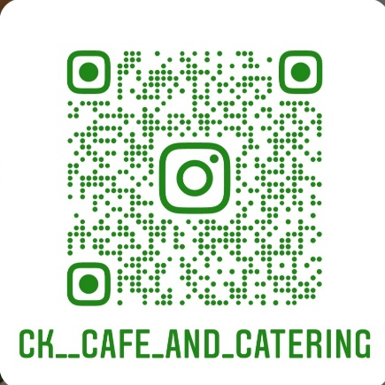

Thanks for stopping in!

